WHEN DO YOU VACCINATE AGAINST ENZOOTIC ABORTION OF EWES (EAE)?

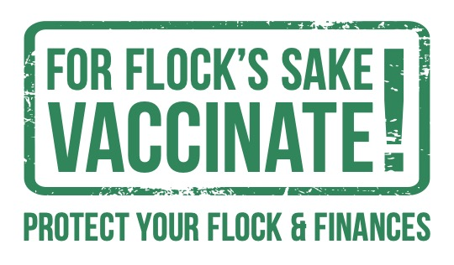

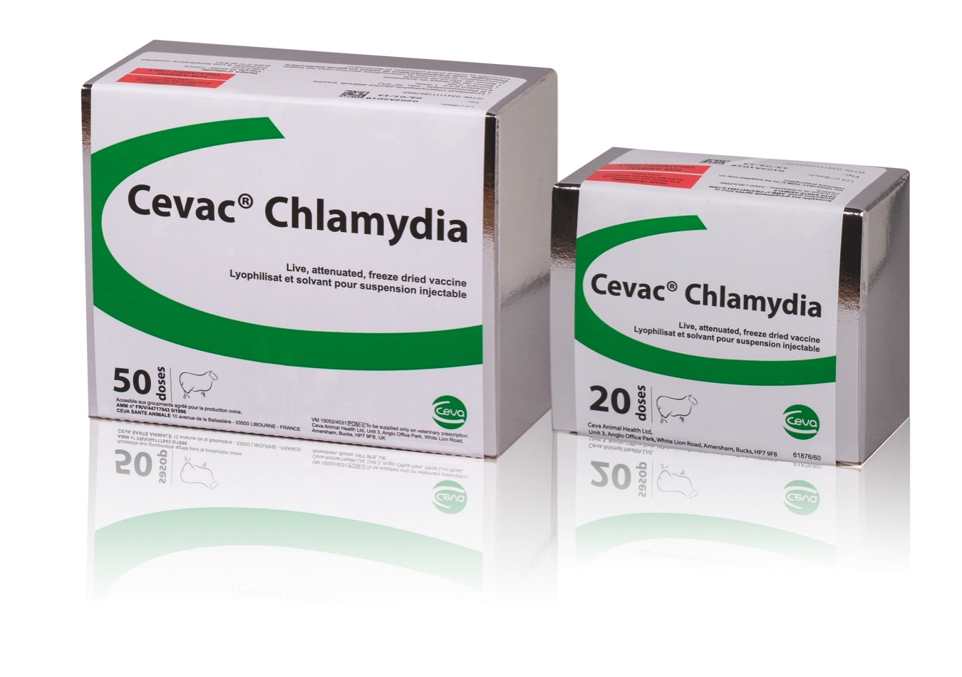
DID YOU KNOW THAT IT CAN BE DONE WHEN IT’S MOST CONVENIENT FOR YOU?

- Cevac Chlamydia can be given from 4 months to 4 weeks before the rams go in
- It can be given from 5 months of age to allow ewe lambs to be vaccinated and protected.
- DO NOT use in pregnant sheep

The disease:
- Enzootic abortion of ewes remains one of the most common causes of abortion diagnosed in sheep, despite the availability of cost-effective vaccines.
- The bacterium (Chlamydophila abortus) is spread from sheep to sheep, predominantly at lambing, when affected ewes will shed large numbers of bacteria in their foetal fluids and placenta
- Infection in a flock can result in the birth of dead and/or weak lambs from about 3 weeks before lambing is due to start.
- If sheep are infected after about 100 days of pregnancy they will not abort at this lambing, the bacteria become latent but then reactivate causing abortion at the subsequent lambing.
- The highly infectious nature of Chlamydia, as well as this latent infection means that levels of abortion can be relatively low one year, before resulting in a storm and significant losses in the next year.
- Some ewes may not abort but can still shed the bacteria, meaning neonatal ewe lambs could be infected.
- In a previously uninfected flock the infection is generally bought in.

Diagnosis:
- If you see an abortion rate over 2% of your ewes lambs then an infectious cause is likely.
- Don’t leave it until after lambing – the best diagnostic results are with fresh samples.
- Take advice from your vet about the best method.

Control:
- Biosecurity and hygiene are important.
- Ensure ewes that abort are isolated and the placenta and bedding is disposed of, so as to minimise transmission to other sheep.
- Consider the history of where you are buying sheep from and ideally, keep bought-in separate from home-bred replacements until they have lambed for the first time.
- The best way to prevent disease is through robust biosecurity and a robust vaccination policy.
- There are 2 types of vaccine available on the market, live or dead. Dead vaccines need a primary course of 2 injections and then a booster. Live vaccines require just a single shot that provides long-lasting protection (3-4 lambings, depending on the disease risk).

