ANTIBIOTICS AND ABORTION!

Abortion continues to have significant impact on UK sheep flock health and productivity. The total cost per single abortion can be significant, as it’s not just the loss of lambs that must be considered but other factors, such as costs of feeding the ewe through pregnancy.

Enzootic abortion remains the most commonly diagnosed cause of abortion across the UK (42% of diagnoses in 2020). EAE is caused by Chlamydophila abortus and is infectious, meaning it can be passed from sheep to sheep. The complication is that sheep infected after 100 days of pregnancy will lamb normally that year but in the next lambing, will abort due to latent infection.

As Chlamydophila abortus is sensitive to oxytetracycline, the blanket use of this antibiotic in the pre-lambing period has been a common way to try and minimise losses. This is not best practice for a number of reasons:

- To be effective, the antibiotic needs to be given in a very narrow window of about 90 – 100 days of pregnancy and more than one injection may be needed, therefore increasing handling and stress on ewes in late pregnancy.
- The antibiotic reduces some of the clinical signs but does not prevent excretion or spread of the bacteria so is only a stop gap, not a strategy for long term success.
- With increasing pressure on responsible use of antibiotics from all angles, blanket use of oxytetracycline in this way must stop, unless advised by your vet in very specific circumstances (see below).
- Effective vaccines are available that prevent disease and reduce shedding, and therefore transmission. Vaccination is the best and most cost-effective way to control this bacteria and associated disease.

As an industry, the UK sheep sector must move away from blanket use of oxytetracycline in cases of EAE except (and with consultation with vets):

- In the face of an outbreak
- In the first year following diagnosis and in conjunction with vaccination, to minimise losses associated with latently infected ewes.

The most recent report on antibiotic use in UK farmed animals is positive, with UK sales of antibiotics to treat food producing animals having halved since 2014. The UK retains a position of fifth-lowest sales of antibiotics for food producing animals in Europe, the lowest among more commercially productive European countries. However, the message remains:

Use all antibiotics responsibly, “as little as possible, as much as necessary”

The continuing emergence of antimicrobial resistance places a responsibility on us all, as an industry (pharmaceutical companies, vets and farmers) to use all antibiotics responsibly.

This same report highlights 3 areas of focus for the reduction of antibiotic use in the sheep sector:

- Control of infectious lameness
- Control of EAE
- Treatment of lambs against neonatal bacterial infections

It also states that blanket treatment should always be avoided.
Prevention of enzootic abortion relies on diagnosing the issue and putting a vaccine plan into place.

Please call the practice to discuss when and how to investigate abortion/still births/sheep scanned in lamb that then do not produce.

PLAN / PREVENT / PROTECT – how to approach EAE

Plan ahead:
- Replacement ewes are the primary source of infection in EAE-naïve flocks. If it is necessary to buy in replacements, an effective biosecurity plan is required.
- Diagnosis of the cause of abortion is essential for ongoing control. Aborted material should be taken for laboratory diagnosis and aborted ewes clearly identified for blood sampling.
Prevent disease:
- An aborting ewe is the primary source of infection for Chlamydia abortus. Therefore, to reduce the risk of infection from any aborting ewe, isolate the ewe from the rest of the flock as soon as possible and remove all the placenta and associated bedding.
Protect the flock:
- Vaccination is the key to protection. It is much more effective when administered before any exposure to disease.
- In the first year all breeding females should be vaccinated and all replacement females done in subsequent years.
- Using Cevac, ewe lambs can be vaccinated from 5 months of age and breeding females can be done from 4 months to 4 weeks prior to the planned introduction of rams. In most situations a single vaccination will last for a ewe’s lifetime.

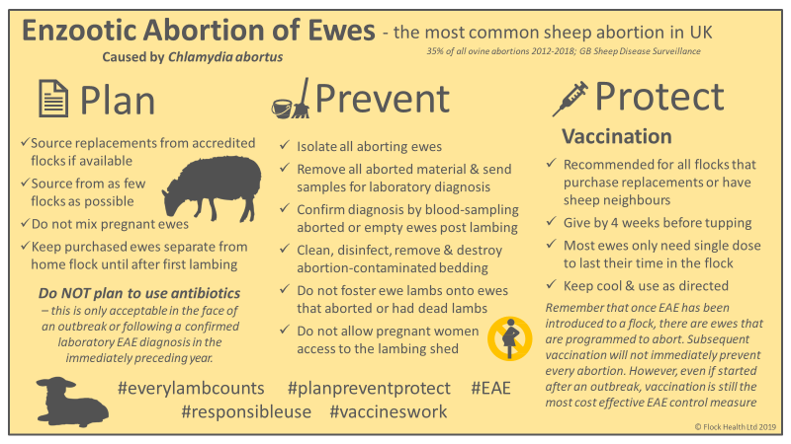Image courtesy of Flock Health Ltd

